**One-Way Between Groups ANOVA**

One-way between groups analysis of variance (ANOVA) is the extension of the two independent sample t-test to the situation in which more than two groups are compared simultaneously.

Both the between groups t-test and the repeated measures t-test extend to ANOVA designs and analysis. It is also possible to combine between groups comparisons and repeated measures comparisons within the one design.

In this module, however, we consider between groups designs only.

ANOVA methods are very widely used and are very flexible which is why we are focussing on them so much.

**Terminology**

Note the use of 'one-way' in the title. This indicates that only *one* Independent Variable (IV) is being considered (also sometimes called one *factor*).

(For later : When we come to consider two IVs (or factors) at the one time we get a *two-way* ANOVA and a *factorial* design. )

A factor in a one-way ANOVA has two or more *levels*. Normally there only two to five levels for the IV, but theoretically it is unlimited. Note that Howell (Chapter 11) describes this design and analysis technique as a "Simple" Analysis of Variance! T-tests can be done using the one-way procedure (i.e., with two levels); in which case, the F you get will be equal to t2.

**General comments**

Although ANOVA is an extension of the two group comparison embodied in the t-test, understanding ANOVA requires some shift in logic. In the t-test, if we wanted to know if there was a significant difference between two groups we merely subtracted the two means from each other and divided by the measure of random error (standard error). But when it comes to comparing three or more means, it is not clear which means we should subtract from which other means.

For example, with five means,

|  |  |  |  |  |
| --- | --- | --- | --- | --- |
| Mean 1 | Mean 2 | Mean 3 | Mean 4 | Mean 5 |
| 7.0 | 6.9 | 11.0 | 13.4 | 12.0 |

we could compare Mean 1 against Mean 2, or against Mean 3, or against Mean 4, or against Mean 5. We could also compare Mean 2 against Mean 3 or against Mean 4, or against Mean 5. We could also compare Mean 3 against Mean 4, or against Mean 5. Finally, we could compare Mean 4 against Mean 5. This gives a total of 10 possible two-group comparisons. Obviously, the logic used for the t-test cannot immediately be transferred to ANOVA.

Instead, ANOVA uses some simple logic of comparing variances (hence the name 'Analysis of Variance'). If the variance amongst the five means is significantly greater than our measure of random error variance, then our means must be more spread out than we would expect due to chance alone.

http://www.une.edu.au/WebStat/unit_materials/c7_anova/image82.gif

If the variance amongst our sample means is the same as the error variance, then you would expect an F = 1.00. If the variance amongst our sample means is greater than the error variance, you would get F > 1.00. What we need therefore is a way of deciding when the variance amongst our sample means is *significantly* greater than 1.00. (An F < 1.00 does not have much importance and is always > 0.0 because variance is always positive.)

The answer to this question is the distribution of the *F-ratio*. An F-ratio is merely the ratio of *any two variances*. In the case of the between groups ANOVA, the variances we are interested in are the two nominated above.

F distributions depend on the degrees of freedom associated with the numerator in the ratio and the degrees of freedom associated with the denominator. Figure 7.1 shows three different F distributions corresponding to three different combinations of numerator df and denominator df.

**Figure 7.1. Different F distributions** for different combinations of numerator and denominator degrees of freedom. Notice "variance expected from sampling error" is sometimes called "WITHIN" variance or "within-subjects" variance, which indicates where it comes from.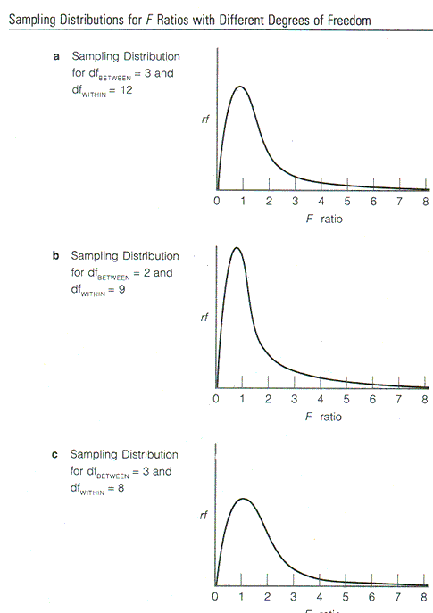

You will see that each distribution is *not* symmetrical and has a peak at about F = 1.00. With degrees of freedom = 3 and 12, a calculated F-value greater than 3.49 will be a *significant* result (p < .05). If the calculated F- value is greater than 5.95, the result will be significant at the alpha= .01 level. With 2 and 9 df, the corresponding values are 4.26 and 8.02. (You will be pleased to know, that there are no one-tailed tests in ANOVA.)

**Variance**

Variance was covered earlier but as a reminder . . .

variance = standard deviation2

In ANOVA terminology, variance is often called *Mean Square*. This is because

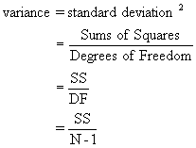

That is, variance is equal to Sums of Squares divided by N-1. N-1 is approximately the number of observations, so variance is an *average Sums of Squares* or *Mean Square* for short.

|  |  |  |  |  |  |  |  |  |  |  |  |  |  |  |  |  |  |  |  |  |  |  |  |  |
| --- | --- | --- | --- | --- | --- | --- | --- | --- | --- | --- | --- | --- | --- | --- | --- | --- | --- | --- | --- | --- | --- | --- | --- | --- |
| **The summary table**  The *Summary Table* in ANOVA is the most important information to come from the analysis. You need to know what is going on and what each bit of information represents.  **An example Summary Table**   |  |  |  |  |  |  | | --- | --- | --- | --- | --- | --- | | **Source of variation** | Sum of Squares | df | Mean Square | F | Sig. | | Between Groups | 351.520 | 4 | 87.880 | 9.085 | .000 | | Within Groups | 435.300 | 45 | 9.673 |  |  | | Total | 786.820 | 49 |  |  |  |   You should understand what each entry in the above Table represents and the *principles* behind how each entry is calculated. You do not need to know how the Sums of Squares is actually calculated, however.  We earlier defined variance as based on two terms,  http://www.une.edu.au/WebStat/unit_materials/c7_anova/image85.gif  From the above table, the Between Groups variance is 351.52 (i.e., the SS) divided by 4 (the corresponding df). This gives 87.88. The error variance is determined by dividing 435.3 by 45. This gives 9.673.  You need to be able to recognise which term in the Summary table is the **error term**. In the Summary Table above, the "Within Groups" Mean Square is the error term. The easiest way to identify the error term for a particular F-value is that it is the **denominator** of the F-ratio that makes up the comparison of interest. The F-value in the above table is found by dividing the Between Groups variance by the error variance.  The error term is often labelled something like "Within groups" or "within-subjects" in the summary table printout. This reflects where it comes from. The variation within each group (e.g., the 10 values that make up the Counting group) must come from measurement error, random error, and individual differences that we cannot explain.  The F-value is found by dividing the Between Groups Mean Square by the Error Mean Square. The significant F-value tells us that the variance amongst our five means is significantly greater than what could be expected due to chance. |
| **Degrees of freedom**  **How the degrees of freedom are determined in the ANOVA Summary table is also worth knowing. This provides a way of checking if you have all the right bits in the table. In more complex designs, SPSS splits the output into Between groups effects and Within-subjects (i.e., repeated measures) effects. You need to be able to bring all the bits together.**  **An important point to keep in mind is that the Total degrees of freedom should be one less than the total number of observations making up the analysis. Here we had 50 bits of information, so the total degrees of freedom are 49. This 49 has been partitioned into two sources � 4 from the number of means being compared (i.e., k-1 = 5 � 1 = 4) and n-1 from each sample. Here, with 5 samples of 10 people each, gives 9 degrees of freedom from each sample � giving the df for the error term as 5 X 9 = 45.**  **Statistical hypotheses**  **Ho: µ1 = µ2 = µ3 = µ4**  **H1: µs not all equal**  **So, if we find that the test statistic (F, in this case) is too unlikely given the null hypothesis, we reject the null in favour of the alternative. In this case, accepting the alternative implies that there is a difference somewhere among our means. At least two of the means are significantly different to each other. If there are only two groups being compared we can automatically assume that they are significantly different to each other. However, if there are more than two we can never be sure exactly which means are significantly different to which other ones until we explore the findings further with post hoc tests.** |